What is manage.py?
manage.py is a python program or commandline utility.
This command or program is used for performing following operations

- Create application
- Database migrations
- Manage Static Resources
- Running server
- Creating superusers
- Django shell
- Debugging

How to create application?
Basic steps for creating project and application

- Open VSCODE
- Open Terminal
- PS C:\Users\Satish Gupta> cd D:\Backup\Django9amMar
PS D:\Backup\Django9amMar>
- PS D:\Backup\Django9amMar> django-admin startproject project2
- PS D:\Backup\Django9amMar> cd project2
- PS D:\Backup\Django9amMar\project2> python manage.py startapp app1

Open Your Project in VSCODE

- File 🡪 Open Folder
- Open Project Folder

Project container folder consists of,
- Application Folder (Package)
- Package (project name)
- Manage.py

Application folder consists of the following modules.
Whenever application is created, manage.py create package with application name.
- Views.py
- Models.py
- Admins.py
- Apps.py
- Tests.py

Project folder contains the configuration modules
- asgi.py
- wsgi.py
- urls.py
- settings.py

Views.py
Django application is developed using an architecture called MVT
- M 🡪 Model
- V 🡪 View
- T 🡪 Template

View is a python program, which receives request/input from client, process it and generate output/response.

View acts as a controller, which control the flow of execution of web application. View communicates with model and templates.

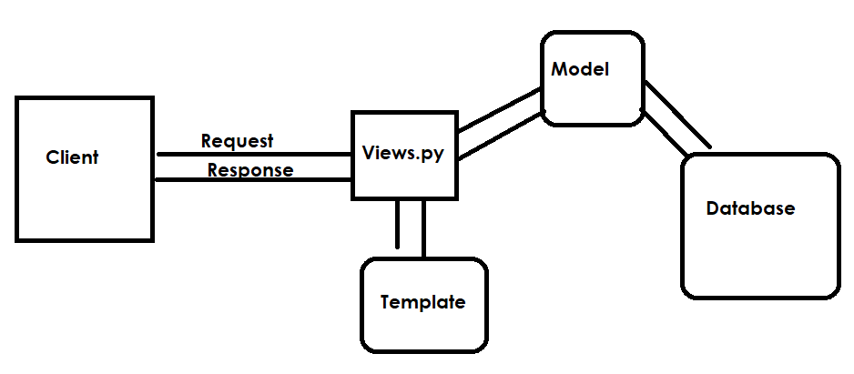

models.py
models.py represents database
models.py is used for representing database models(tables).

admins.py
This module is used for configuring models with admin application
Customization of admin application is done using this module.

apps.py
This is application configuration module

tests.py
This module is used for writing test cases for testing web application.

Project configuration package contains the following modules,

- asgi.py
- wsgi.py
- urls.py
- settings.py

